Heart Beat Classification using Machine Learning

ABSTRACT
Accurate classification of heartbeat signals is essential for the early detection and diagnosis of cardiac anomalies. This study leverages a hybrid architecture combining Convolutional Neural Networks (CNNs) and Long Short-Term Memory (LSTM) networks to analyze electrocardiogram (ECG) signals. The CNNs extract local features, while LSTMs capture temporal dependencies, enabling robust classification. The PTB dataset was used for binary classification, and the MIT-BIH dataset for multi-class classification into five heartbeat categories, with preprocessing steps including dataset balancing, normalization, and spectrogram generation. The model, trained with binary cross-entropy loss and evaluated using metrics such as accuracy, precision, recall, and AUC, demonstrated superior performance in detecting cardiac anomalies. Despite challenges like class imbalance and noisy data, the results underscore the potential of CNN-LSTM architectures for improving cardiac diagnostics.
Keywords–Heartbeat Classification, Electrocardiogram (ECG) Signals. Recurrent Neural Networks (RNNs), Long Short-Term Memory (LSTM) Networks

- INTRODUCTION

Arrhythmia refers to an irregular frequency or rhythm in a patient's heartbeat. While most arrhythmias pose minimal threats to human health, certain types, such as rapid atrial fibrillation, paroxysmal supraventricular tachycardia, and persistent ventricular tachycardia, can lead to severe symptoms or complications [1]. These conditions may manifest as palpitations, chest discomfort, dizziness, low blood pressure, sweating, fainting, and, in extreme cases, sudden death. Therefore, symptomatic arrhythmias demand immediate medical attention. Among these, atrial fibrillation (AF) is the most common sustained arrhythmia, contributing significantly to the risks of heart failure, dementia, and stroke. This type of supraventricular tachycardia is associated with considerable morbidity and mortality. The prevalence of AF escalates with age and is more commonly observed in men than women. For instance, in 2009, AF affected approximately 1–2% of the global population, and projections suggest that the number of AF patients in Europe and the United States could double or triple over the next 20–30 years [2]. In developing countries, the prevalence of AF is slightly lower, with around 0.6% of men and 0.4% of women being affected. In China, the age-adjusted prevalence is reported to be 6.5 per 1000 individuals, primarily among those aged 60 years and older, and remains lower compared to Western nations, particularly in middle-aged groups. Besides AF, other serious arrhythmias include atrial flutter, bradycardia, and ventricular bigeminy, which also require precise diagnosis and treatment.

Globally, tachyarrhythmias are responsible for approximately half of all cardiovascular deaths and contribute to 15% of total mortality. Consequently, rapid and accurate detection of abnormal heart rhythms is critical, particularly for middle-aged and elderly populations. The electrocardiogram (ECG) is a widely used, non-invasive tool that monitors and graphically records the heart's electrical activity, providing valuable insights into cardiac function. However, due to the non-linear nature of ECG signals and their low amplitude, subtle changes in the data often go unnoticed by human observation. Additionally, obtaining a comprehensive diagnosis typically requires long-term monitoring, such as 24-hour Holter recordings, which can be tedious and time-consuming for manual analysis. This highlights the need for automated diagnostic tools to improve the efficiency and accuracy of ECG [3].
The medical image analysis community has taken notice of these pivotal developments. However, the transition from systems that use handcrafted features to systems that learn features from the data has been gradual. Before the breakthrough of Alex Net, many different techniques to learn features were popular. Bengio et al. (2013) provide a thorough review of these techniques. For example, rule-based systems, as demonstrated by Sufi et al., have achieved high accuracy in diagnosing ventricular fibrillation and other cardiac abnormalities. Similarly, Martis et al. employed independent component analysis (ICA) and k-nearest neighbor classifiers to distinguish between normal, atrial fibrillation, and atrial flutter signals with remarkable sensitivity and specificity. Despite their efficacy on specific datasets, these methods often suffer from poor generalization, overfitting, and reduced performance when tested on new data. Deep learning has emerged as a powerful alternative to traditional techniques, offering significant improvements in both generalization and feature extraction.

Page 1

Convolutional Neural Networks (CNNs) have become a preferred method for medical image interpretation, including cardiac imaging, due to their robustness against noise and their ability to learn hierarchical features through deep-layered structures [4]. For example, Acharya et al. developed an 11-layer CNN model capable of classifying four arrhythmia types with high accuracy using ECG data. Additionally, Oh SL et al. combined CNNs and Long Short-Term Memory (LSTM) networks to classify variable-length ECG signals effectively. Yildirim et al. further enhanced ECG beat classification using bidirectional LSTM networks and wavelet sequences, showcasing the potential of deep learning in ECG analysis.
In general, although these methods show good performance in the ECG diagnosis of a known database, they do not perform well in practice owing to various shortcomings, such as poor generalization performance for new data. When validated using an independent dataset, these systems demonstrate an ECG classification performance that is not as good as that with a known dataset, and the systems show overfitting [8,4].
A logical next step is to let computers learn the features that optimally represent the data for the problem at hand. This concept lies at the basis of many deep learning algorithms: models (networks) composed of many layers that transform input data (e.g. images) to outputs (e.g. disease present/absent) while learning increasingly higher-level features. The most successful type of models for image analysis to date are convolutional neural networks (CNNs) [5,10]. These performance characteristics are reflected in a layer-by-layer network structure. As the layers in the network deepen, features are learned and represented in a more abstract and concise manner. Currently, there are numerous methods for analysing ECG signals based on deep learning.
Despite these advancements, many existing methods face limitations, such as a reliance on single datasets, lack of cross-validation, and insufficient incorporation of key rhythm features like inter-beat intervals [2,4]. To overcome these shortcomings, this study proposes a novel deep learning approach that combines CNN and LSTM architectures. By integrating ECG segments and RR intervals as multiple inputs, this method enhances spatial and temporal feature extraction, improving classification performance across six ECG classes: Normal (N), Atrial Fibrillation (AFIB), Bradycardia (B), Premature (P), Atrial Flutter (AFL), and Aberrant Rhythm (ABR). The proposed model is validated on multiple databases[5,9], including MIT-
BIH Arrhythmia, Atrial Fibrillation, and Normal Sinus Rhythm Databases, to assess its generalization and reliability.
,

are not directly applied as the network input.
In addition, previous studies used a single database to verify the results, and there was no independent cross-validation[9].
Considering the advantages and disadvantages of the existing methods, this study proposed a classification method based on deep learning for ECG signals that can analyze and recognize six classes of ECG segments, including N, AFIB, B, P, AFL, and ABR. In addition to automatic feature extraction of the CNN from the ECG, the interval between two adjacent R peaks (RR interval) is also inputted into the model as an auxiliary feature of the ECG signals to improve the identification performance [3].
To extract the spatial information and time information of the ECG signals and improve the abstraction ability of the model, this study combines CNN and LSTM as a new network structure with ECG fragments and RR intervals as multiple inputs. To evaluate the generalization performance, the method was validated on the MIT-BIH arrhythmia database and two other databases: The MIT-BIH Atrial Fibrillation Database (AFDB) and the MIT-BIH Normal Sinus Rhythm Database (NSRDB) [6].
This method tackles the challenges of conventional diagnostic techniques by enhancing the precision and speed of arrhythmia detection through automated analysis. By utilizing both rhythm-related and structural features, the proposed model achieves superior generalization and abstraction. The combination of CNN and LSTM architectures allows for effective identification of intricate patterns in ECG data. This advancement aims to support clinical practices by enabling more accurate diagnoses and better treatment strategies for arrhythmia s[9].
This study aims to advance ECG signal analysis by leveraging deep learning techniques, providing a more accurate, robust, and efficient solution for arrhythmia diagnosis.
2. LITERATURE REVIEW
Due to its potential to enhance cardiac diagnostics, machine learning and deep learning have been actively researched for the categorisation of heartbeat signals. For processing sequential data .The accurate identification of arrhythmias remains a crucial focus in cardiac healthcare, with extensive research dedicated to improving diagnostic techniques. Early methods for ECG signal analysis relied heavily on traditional computational approaches, such as rule-based systems and machine learning classifiers. For instance, rule-based techniques have demonstrated high accuracy in detecting specific conditions, such as ventricular flutter and atrial fibrillation, by leveraging predefined patterns within ECG data. Similarly, machine learning methods like k-nearest neighbor (k-NN) classifiers have been used to classify arrhythmias by extracting meaningful features from ECG signals [7,8]. Despite their effectiveness on curated datasets, these methods often struggle with generalization, making them less reliable when applied to new or varied datasets.

Page 2
such as electrocardiogram (ECG) signals, Recurrent Neural Networks (RNNs) and Long Short-Term Memory (LSTM) networks have shown great promise among other methods.
1. Recurrent Neural Networks (RNNs): RNNs are a type of neural network that records temporal relationships over time steps by preserving a hidden state. This allows them to analyse sequential input. This qualifies them for uses including voice recognition, ECG signal processing, and time-series forecasting.
3. Long Short-Term Memory (LSTM) Networks: LSTM networks are a specific kind of RNN that can recognise long-term relationships in sequences by using gated mechanisms to solve the vanishing gradient problem.
3.GRU Gated Recurrent Unit:
Using the Keras package, the build_gru_model method specifies the architecture of a Gated Recurrent Unit (GRU) model. Recurrent neural networks (RNNs) of the GRU type are very good at processing sequential data, such as text or time series.
This function essentially specifies a neural network design based on GRU for categorising sequential input into five groups. It consists of a final dense layer to generate the classification output, two GRU layers, and dropout for regularisation
4. OBJECTIVE
In order to help in the early identification of cardiac disorders, the main goal of this project, "Heartbeat Classification Using CNN and LSTM Networks for Early Detection of Cardiac Anomalies," is to create a deep learning-based system for the automated categorisation of heartbeat data. Using datasets like PTB and MIT-BIH, the research seeks to categorise ECG signals into many categories for multi-class classification and into normal and pathological categories for binary classification[9]. The suggested framework aims to increase classification accuracy and reliability by combining Long Short-Term Memory (LSTM) networks for modelling temporal relationships and Convolutional Neural Networks (CNNs) for feature extraction. Additionally, the research uses sophisticated preprocessing methods including data balancing, spectrogram creation, and normalisation to solve issues like class imbalance and loud ECG signals.
Proposed Method
In order to capitalise on their individual advantages in feature extraction and temporal modelling, the suggested approach for heartbeat classification combines Convolutional Neural Networks (CNNs), ,GRU(Gated Recurrent Unit ) and Long Short-Term Memory (LSTM) networks.
4.1 Initial Preparation
The ECG data goes through the following preparation procedures to guarantee the model functions properly.

Data Balancing: Using oversampling and under sampling strategies to address the class imbalance in the PTB and MIT-BIH datasets.
Normalisation: To improve training stability, scale the ECG signals to a constant range.
Spectrogram generation is the process of transforming unprocessed ECG data into frequency-domain representations in order to get fine-grained CNN layer information
4.2 Data Loading and Preprocessing:
A training set and a testing set, loaded as CSV files, were used in the study. To make sure there were no missing or duplicate values, the datasets were evaluated for integrity and completeness. Analysis of the target variable's class distribution showed inequalities between categories. The frequency of samples by class was displayed in a bar plot, emphasising the structure of the data. For the sake of clarity in the study that followed, numerical class labels were translated to descriptive words.
Preview of Data:
train data: A Pandas Data Frame is likely stored in this field. Data may be arranged in rows and columns using a Data Frame, a data structure that resembles a table.
A method named ". head()" is invoked on the train_data Data Frame. Pandas has a built-in method that, by default, shows the Data Frame’s top five rows. The user wishes to visually examine the top part of the data by executing train data. head() in order to gain a preliminary knowledge of its properties, including the names of the columns and the kinds of values it includes
Label Mapping:
In essence, this labels dictionary maps numerical labels (0–4) to their descriptions that are legible by humans. In machine learning, particularly in classification issues, this is quite prevalent. Numerical data is frequently used in models, and algorithms typically use numbers rather than text labels. Human interpretation is crucial because we want to be able to comprehend the model's predictions in a way that makes sense to us.
4.3 Visualization of Class Distribution:
This line of code is in charge of producing and presenting a bar plot that shows how the various classes are distributed throughout the training dataset (train_data). In essence, it displays the data
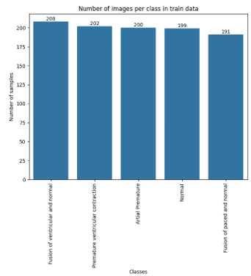
Page3
Early Stopping: To prevent overfitting and conserve processing power, training ends when the validation loss remains constant.In essence, this code visualizes the training history of the model by plotting the recorded metrics over the epochs, helping to understand how the model's performance evolved during training.
Algorithm 1: Long Short-Term Memory (LSTM)
Overview
LSTMs are a specialized type of Recurrent Neural Network (RNN) designed to address the vanishing gradient problem and effectively capture long-term dependencies in sequential data. They use a sophisticated cell structure with gate mechanisms.
Key Components of LSTM
- Cell State: Stores information over extended periods and acts as the memory component.
- Input Gate: Regulates the flow of new information into the cell state.
- Forget Gate: Determines which information from the previous cell state should be discarded.
- Output Gate: Decides which information from the cell state is output at the current time step.
How LSTMs Work
- Input: The current input and the previous hidden state are fed into the LSTM cell.
- Cell State Update: Combines the old state, new input, and forget gate's decision.
- Output: The output gate processes the updated cell state to produce the final output.
Advantages of LSTM
- Effective Handling of Long-Term Dependencies: Ideal for tasks involving long sequences, such as language modeling and time series analysis.
- Robustness to Vanishing Gradients: The gate mechanism mitigates this issue, enabling deep LSTM networks to be trained effectively.
- Versatility: LSTM architectures can be customized for various applications.
Applications
- Natural Language Processing: Text generation, machine translation, sentiment analysis.
- Speech Recognition: Automatic speech recognition systems.
- Time Series Analysis: Stock price prediction, weather forecasting.
- Anomaly Detection: Identifying unusual patterns in data streams.
Algorithm 2: Recurrent Neural Networks (RNNs)
Overview
RNNs are artificial neural networks designed to
process sequential data. Unlike traditional.
feedforward networks, RNNs have directed cycles, allowing them to maintain a "memory" of past inputs and capture long-term dependencies
Core Concepts of RNNs
- Sequential Data: Effective for tasks where the order of elements matters (e.g., text, audio, video).
- Memory: Hidden states store past input information, influencing the network's current output.
- Backpropagation Through Time (BPTT): Training algorithm for calculating gradients through multiple time steps.
Applications
- Natural Language Processing: Text generation, machine translation, sentiment analysis.
- Speech Recognition: Automatic speech recognition systems.
- Time Series Analysis: Stock price prediction, weather forecasting.
- Anomaly Detection: Identifying unusual patterns in data streams.
By leveraging their sequential memory capability, RNNs and their variants like LSTMs and GRUs address complex sequential data challenges across various domains
3.Gated Recurrent Unit (GRU) Algorithm
The Gated Recurrent Unit (GRU) is a type of Recurrent Neural Network (RNN) optimized for sequential data like text or time series. It uses gating mechanisms to manage information flow effectively, ensuring efficiency and reliability in processing sequences.
Key Gates in GRU
- Reset Gate:
Controls how much past information to forget.
Helps focus on relevant input for the current step.
- Update Gate:
Determines what information should be retained and passed forward.
Balances the trade-off between retaining past information and updating with new data.
Applications of GRU
- Text Classification:
Sentiment analysis, topic categorization, and language modeling.
- Time-Series Forecasting:
Stock prediction, weather forecasting, and anomaly detection.
- Speech and Audio Processing:
Speech recognition, voice activity detection, and sound classification.
GRUs are versatile, computationally efficient, and highly effective for tasks requiring sequential data analysis.

Page 4

Result and discussion
Results of the MIT-BIH database
The method for the MIT-BIH database was verified, and the data are shown in label 1 of Fig. 3. The five-fold cross-validation strategy was employed. A stratified random test was performed by dividing the data into five equal portions. At each validation, 80 % of the data for model training was used, and the remaining 20 % of the data was used for model testing. The test was repeated five times until all data were tested.
Discussion
Many studies on automatic ECG arrhythmia recognition have been performed based on the MIT-BIH arrhythmia database, as listed in Table 11, Table 12. To compare the literature in Table 11 (for the ECG beats analysis), an ECG segment of 10 s (instead of an ECG beat) was analyzed, which provided initial heartbeat rhythm information and was consistent with the diagnosis of short-term continuous signals by doctors. Compared with the literature [1for the ECG segment
5. Evaluation
5.1.RNN Model Training and Evaluation:
Using pre-prepared data, the RNN model tracks its performance on a validation set and displays the learning process using accuracy and loss charts. This graphic aids in evaluating the model's training progress and spotting any problems like as overfitting
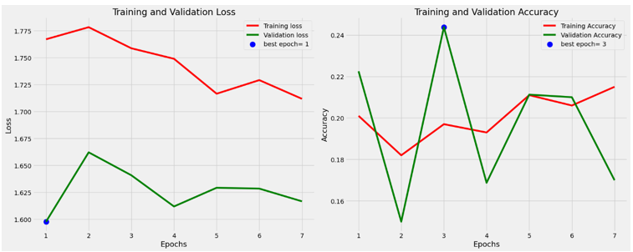
In essence, this code visualizes the training history of the model by plotting the recorded metrics over the epochs, helping to understand how the model's performance evolved during training.
5.2.Confusion Matrix for RNN:
RNN's predictions and the true labels, creates a confusion matrix to summarize the model's performance, and then presents the matrix as a visually informative plot, aiding in understanding where the model is performing well and where it might be making mistake.
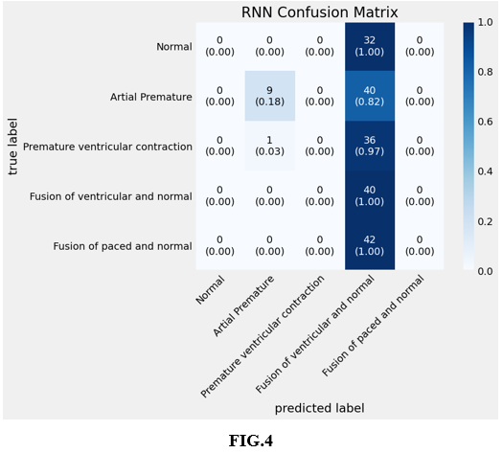
Visualizing GRU Model Training Performance
with Learning Curves:
In this line of code, the learning_curves_plot function is essentially told to take the training history data that is stored in gru_history and plot it to demonstrate how the accuracy and loss of the GRU model changed across epochs on both the training and validation sets. This graphic aids in evaluating the model's functionality and spotting any problems such as underfitting or overfitting
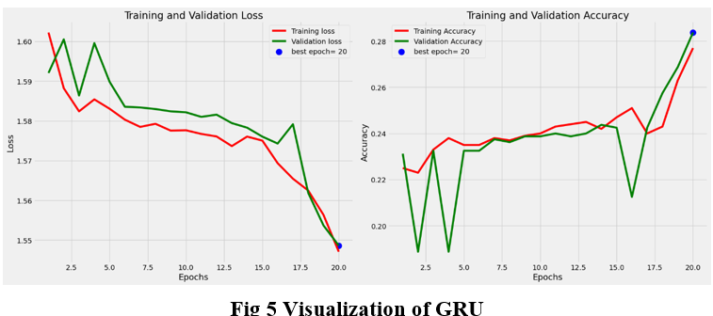
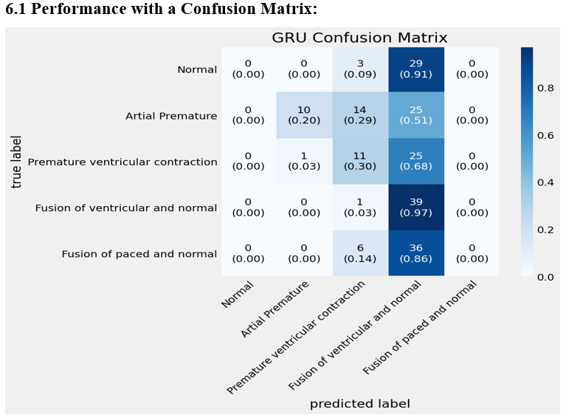

Page 5

6.2 Visualizing LSTM Model Training Performance with Learning Curves
By producing visual depictions of the LSTM model's performance over time, snippets are essential for tracking and evaluating the model's training behaviour. The model is then improved using this data to guarantee that it is efficient for the desired purpose.
In essence, this code block takes the calculated performance metrics (acc, f1, and cm) and presents them in a user-friendly format on the output. This helps to quickly understand how well the model is performing on the given task.
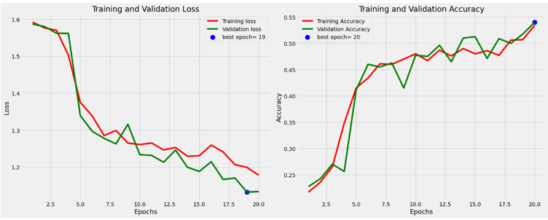

6.3 Confusion matrix for LSTM
An illustration of the LSTM model's confusion matrix. It normalises the data for easier understanding and labels them using the filtered class names. Lastly, a title is shown along with the storyline.
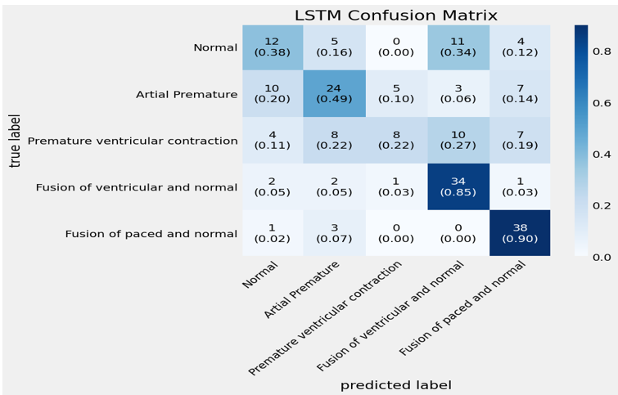
CONCLUSION
The goal of the study was to use an LSTM model to reliably categorise heartbeat signals. Strong performance metrics were shown by key findings, underscoring the model's potential to aid in the early diagnosis of cardiac problems. All things considered, this study emphasises how AI might improve heart health monitoring.

III .References

1. Arrhythmia on ECG Classification using CNN

2.https://ieeexplore.ieee.org/document/10286090
3.https://ieeexplore.ieee.org/document/9027740
4.Automated arrhythmia classification based on a combination network of CNN and LSTM - ScienceDirect
5.
https://www.sciencedirect.com/science/article/abs/pii/S0020025517306539

6.https://www.sciencedirect.com/science/article/pii/S0167739X17324548

7.https://www.sciencedirect.com/science/article/abs/pii/S1361841516000128

8.https://www.sciencedirect.com/science/article/abs/pii/S0196064415014742

9.https://www.sciencedirect.com/science/article/pii/S1746809416300830

10.Https://www.sciencedirect.com/science/article/pii/S1746809413001213

Page 6

